Queues: listas de elemento para procesar con varios robots

Por ejemplo: la lista de emails en un archivo excel

Usaremos 2 proyectos

Uno que carga y otro que procesa la lista

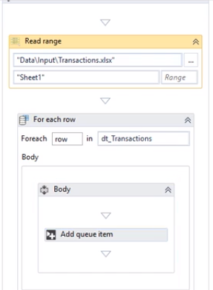

Lee excel y lo carga a queue

Al crear cola

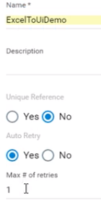

Le puede decir que es unico el valor

Y le puede decir cuantas veces Retry si falla la carga

Business Exception vs Application Exception

It is important to choose the correct type of exception with which a transaction is failed, because this choice influences whether **Orchestrator** chooses to retry the transaction of the queue item or not, as follows:

* An **Application Exception** describes an error rooted in a technical issue, such as an application that is not responding.  
  A project which extracts phone numbers from an employee database, creating queue items for each of them. These items are then to be processed and inserted into a financial application. If, when the transaction is attempted, the financial application freezes, the Robot cannot find the field where it should insert the phone number, and eventually throws an error.  
  These kinds of issues have a chance of being solved simply by retrying the transaction, as the application can unfreeze.
* A **Business Exception** describes an error rooted in the fact that certain data which the automation project depends on is incomplete or missing.  
  a project which extracts phone numbers from an employee database, creating queue items for each of them. These items are then to be processed and inserted into a financial application. If a certain phone number is missing a digit due to human error, the queue item containing it becomes invalid. This causes the automation to throw an exception, as the Phone Number field in the financial application does not accept a queue item that contains an incomplete number.  
  Retrying the transaction does not yield any chance of solving the issue, and there are other better courses of action, such as notifying the human user of this error.

The **Set Transaction Status** activity can be used to shape the logic of your project in a way that encapsulates this distinction in several ways:

* If the **Set Transaction Status** activity fails the transaction with an **Application Exception** and the **Auto Retry** option in the Orchestrator Queues page is set to **Yes** when the queue is created, the queue item is retried.
* By default, Orchestrator does **not** retry transactions which are failed due to **Business Exceptions**. This happens because an inconsistency between the transaction value and the business requirement means that there might be errors in the initial data which the queue items were created from. Additional actions might be required to fix this type of issue, and logging this type of exception can be useful.
* An **If** or **Flow Decision** activity can be used to take different courses of action if a transaction is failed with a certain type of exception, such as using the **Log Message** activity to log a custom message or the **Message Box** activity to display a window containing information about the event.

**Item Statuses**

These statuses let you know if an item has been processed or not, and the stage of the process at a particular time. Item statuses are displayed in the **Status** column, in the **Transactions** page. Queue items can go through the following statuses:

* **New** - the item has just been added to the queue with the **Add Queue Item** activity, or the item was postponed or a deadline was added to it.
* **In Progress** - the item was processed with the **Get Transaction Item** or the **Add Transaction Item** activity; when an item has this status, your custom progress status is also displayed, in the **Progress** column;
* **Failed** - the item did not meet a [business or application requirement](https://orchestrator.uipath.com/docs/business-exception-vs-application-exception) within the project and was therefore sent to a **Set Transaction Status** activity, which changed its status to Failed;
* **Successful** - the item was processed and sent to a **Set Transaction Status** activity, which changed its status to **Successful**;
* **Abandoned** - the item remained in the **In Progress** status for a long period of time (approx. 24 hours) without being processed;
* **Retried** - the item failed with an application exception and was retried. After the Robot finishes retrying the item, the status changes to Failed or Successful, according to your workflow.
* **Deleted** - the item has been manually selected from the **Transactions** page and marked as deleted; an item with this status can no longer be processed.

# Revision Statuses

These statuses let you perform version control but **only of queue items that have been abandoned or have failed with an application or business exception**. These statuses have to be manually set per item, by an assigned reviewer. All changes are tracked in the [**History**](https://orchestrator.uipath.com/docs/field-descriptions-transactions#section-the-history-tab) tab of the **Audit Details** window. The reviewer can be assigned only when the item status is failed or abandoned, and reviewers cannot be changed after a revision status was added to the item. Only logged in reviewers can see requests assigned to them in the [**Review Requests**](https://orchestrator.uipath.com/docs/managing-review-requests) page. Moreover, queue items can be assigned for revision in bulk.

[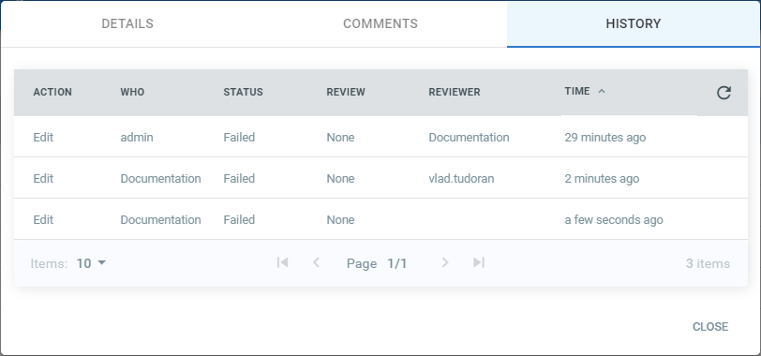](https://files.readme.io/1fca18f-the_history_tab_audit_details_window.png)

The following statuses are available:

* **None** - this is the default status. It is set to all items, even if they failed or not.
* **In Review** - a user has marked an item that has failed with app exception as in the process of being reviewed. This status does not have other implications in Orchestrator or Studio than changing the value in the **Revision** column on the **Queues** page.
* **Verified** - a user has marked an item as verified. Items cannot be retried after the user sets this status. There are no other implications in Orchestrator or Studio than changing the value in the **Revision** column on the **Queues** page.
* **Retried** - the item has been marked manually for retry. As a result, a new queue item with the **New** status is created. This is displayed in the **Items Details** window of the indicated transaction.